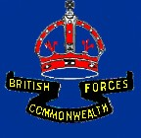

BRITCOM TRANSPORTATION SQUADRON

On return to Sydney from the "TARRA" I went on leave and promptly bought a "Singer 9" sports car. I had hidden my weapons "cache" below the car park opposite the Barrack Block for a week or so and then transferred them to my room and covered them up in my locker and, now that I had them in Sydney, I did not know what to do with them.

One day, in January 1956, I was summoned to appear before the RSM at my room. Even before I got there I knew what it was as if I was at Manly, I would still be able to have heard John Toomey venting his displeasure at what he found. Apparently he went on one of his frequent room inspections and it was just a check to make sure we were on the ball. In my room there were four of us and although the room was 0K, one of the lockers was open and it was mine. John noticed a butt and pulled it out. It was the Owen Gun and on further inspection he retrieved the whole arsenal. He had them laying on the bed, Owen, Thompson, Austen, Ml, Japanese rifle and the 303. I began to get the feeling that I was in big trouble as I think he was about to belt me over the head with his baton. He wanted to know where they came from and I told him the truth that they were souvenirs I had come across in New Guinea. At this admission he near choked and went outside to calm down. After a while he came back in to the room and removed the breech blocks and bolts and told me that the weapons would be removed from Chowder Bay by evening. I remarked that the weapons were not much use without the breech blocks and bolts so could I have them back. He then went off into one of his "primeval tantrums' which he had exposed to us from time to time. Around about this time I thought it would be prudent to keep my mouth shut. He carried on for about 10 minutes and some of the tirade contained "Army offence”, Civil offence , "Customs Offence" , " five years jail dishonourable discharge' etc. . He then stormed out saying there will be a full inspection in the morning. It was just as well he did not have a look in the bedside locker as there was a .45 Automatic pistol and a Webley Air Pistol wrapped in a hand towel.

I then put the weapons in the boot of the Singer. After we finished for the day I went off to see my girlfriend and got a flat tyre at Penshurst (John was a deeply religious RSM and no doubt had a word or two with The Boss). While replacing the tyre a fellow came along and asked if he could help. He had just came out of the Penshurst RSL and his name was Norm Tinsley and an ex- Major from the Sixth Division. He gave me a hand and then I had a brilliant idea in that would the RSL like a few pieces of memorabilia to which he said yes but when he had a look in the boot he was a little apprehensive. We took them into the RSL and that is where they were left. The Thompson is the only survivor as the RSL was severely damaged in a fire in 1985 and the Owen Gun disappeared from the RSL a couple of months after they had been given to them. The Thompson is displayed on the wall. The inspection was held the next morning and even though my space was spotless I received an extra week’s piquet and two weekend duties

Concluding an Army Seaman Class 2 examination and Navigator Class 3 examination my next posting was to BritCom Tn. Squadron in Kure, Japan in Apr 56 as a W02 Navigator (I

Peter James Bayliss, 1992 26

was still a Spr.).The week before I left for Japan I was duty Coxswain for the week and Marshall Story was my deckhand. I had pulled into Watsons Bay in AM1641 to let passengers off and take some on. The wheel was handed over to Marshall as he was a trainee Coxswain and I looked after the lines. He had departed the wharf OK and was running parallel to the wharf heading out. In the meantime I was coiling down the mooring lines at the stern when there was a scream from a WRAAC passenger and as I looked up I saw the Stb. bow smash into a wharf pile. Apparently Marshall had turned to look astern and moved the wheel slightly to Stb and being 20 feet or so from the wharf it wasn't long before the inevitable happened. The force of the collision threw AM1641 to Port. Marshall had reduced power and disengaged the clutch. I quickly had a scan of the passengers but there were no injuries and then I checked the hull. The damage was confined to the Stb bow and the Rubbing Strake and Sponson from the bow to 12 feet Aft was missing. I pulled away from the wharf head about 100 metres and went to the bow and sat there thinking to myself that "I would not be going to Japan after this
! when Marshall came up and said “I don't think that they will like this, back at Chowder
Bay. He was in a perfect position to be thrown overboard but that would have only added to the problem. I think I was a lot more worried that the Wharfmaster, Norm Holdsworth, would thump the daylights out of me than I was about the official reaction to the collision. We continued on and AM1641 carried on as though nothing had happened. The simply don't make boats like the 40' W/Boat anymore. The report of the collision was submitted and I heard no more about it.

I left Mascot on a QANTAS Constellation and when we arrived in Manila the plane was grounded because an engine had failed. We were all booked into the Bayview Hotel which was a magnificent and luxurious hotel until you bought a drink or a packet of cigarettes. A packet of cigarettes cost 8 shillings and a rum/coke cost 4 shillings. To go for a ride in a "Taxi Jeep" was out of the question and one had to be very careful if walking at night. The plane left Manila three days later and arrived Tokyo in blinding rain and very low temperatures.

I spent one night at Ebisu camp and then on a train to Kure. The Japanese trains of 1956 were much faster than our trains are today and a lot more comfortable. One interesting item was that we never seemed to leave a city. The size and number of buildings would diminish in size and number until there was a space of maybe a few hundred yards and then it began to
increase again.

My position with the squadron was NCO IC Craft Control. My main responsibilities here were the daily operations of 22 Craft including Workboats, Landing craft, Salvage craft and Fast Supply craft. I was also Master of AM1734 "KURANDA" a 25 metre vessel used as a VIP vessel by the Commander British Commonwealth Forces Korea. The “KURANDA" had a Japanese Skipper who had been the Master of a Jap
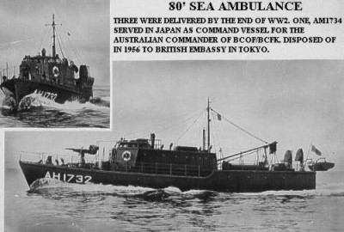

Naval Auxiliary ship during WW2 and had been torpedoed twice. He must have felt a sense of disgust at having a 20 year old Spr. as his superior but he never displayed any emotion at all and in fact was the epitome of politeness and loyalty.
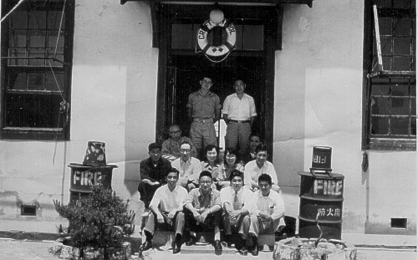

The Admin staff of Britcom Tn. Squadron

Britcom Tn Squadron was a composite Australian and British unit and the unit was now in the final year of its existence and was composed of two sections, Water Tpt and Docks Operating. The Docks section was the largest and of that group the British Army had the Largest component with Australians holding the senior positions. On the Water Transport side There was myself and a British Spr. and Doug Wooten who ran the Workshops. The Unit was commanded by a Maj. (British) with Jim McFarlane as 2IC. There was also a Troop Officer (British). The Sgt. I was relieving was Tony Woodward and he remained for a week running me through the procedures. The SSM of the unit was a British W02 and did not like Australians, I think mainly because he could not understand English. During the week Tony remained with me we found ourselves, one afternoon, doing drill with the Docks people. It was drill without Arms, which to me was the same as Drill with Arms - I was not a Parade Ground soldier. Both of us made ourselves as inconspicuous as possible and were at the "arse end" of the formation. Everything went well until there was an "about turn" and we were now heading the formation. It was, naturally, a shambles but the biggest foul-up occurred when we were given the order "Saluting to the front - Salute". I looked at Tony to see what he was going to do and at the same time he looked at me to see what I was going to do. We both saluted and kept marching - off the Parade Ground and waiting for the order to tell us to stop saluting. In the meantime the Squad had halted, Saluted, paused, saluted again and then about turned and marched back to whence they had come. The CSM was very abusive to us and did not bother to ask us to come back on the Parade Ground.

The unit was based at Point Camp with the Britcom Engr. Regt. which was commanded by Lt. Col Sam Fletcher (Australian). The Australians in Britcom Tn. Sqn. were Jim McFarlane, S /Sgt Jack Webb(original from BCOF), Doug Wooten, Bob McLeod, Wally Malcom, Frank Verdi and "Tiny" Colin Beashel ( Inchon-Korea) and, arriving after me , Norm Holdsworth.

Even at that stage of its existence the Water Tpt. side of the Squadron probably held more craft than the entire Army had in Australia.

The craft held were:-

1. AMl734 "KURANDA"
2. 2 x 62' Command Craft (one on loan to RAAF at Iwakuni)
3. 2 x ALC40
4. 6 x ALC20
5. 4 x 38' Fast Supply
6. 6 x 40' Workboats
7. 1 speedboat (AM698)
8. 1 x Salvage Barge (CB1050)
9. 6 x Philippine Lighters
10. 1 x 75 ton Floating Crane (Steam)

The OC of the Squadron must have had a fit when I arrived on the scene as a Spr. and probably did not like the idea at all. One day he called me into his "inner sanctum" and explained to me that situations where a 20 year old Spr. was posted to a senior NCO (W02) position never arose in the British Army however I would be appointed as a L/Cpl. He obviously did not like my being there at all but he never displayed his displeasure to me which was quite alright with me as I did not like serving under the British and I never displayed my displeasure to him. He did however, have a lot more power than I did and I never forgot that.
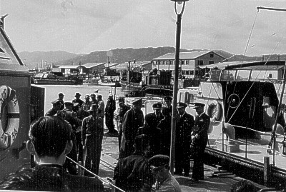

Senior Allied officers boarding "Kuranda" at Iwakuni

The Craft Control system used was perfect and had been perfected since 1946. We did not have to seek tasks as I was to do in New Guinea and Darwin some years later. The unit or agency bidding for Watercraft submitted their bid to Movements. As nearly all tasks involved the pickup or put-down of personnel to either Iwakuni, Etajima, Myajima or to some of the numerous U.S munitions dumps on small nearby islands and/or the task could be completed in one day then Movements rang our office in the morning around 0700 and we were given the days tasks. The crews of all craft reported to the office at 0730 and as each man arrived a token with his name was placed on the Craft status board. The day’s tasks were then allotted to those craft that had a full crew complement. If we were inundated with tasks and did not have enough crewed craft available then Movements applied the priority plan and we then received an amended list. We did not have to assume responsibility for "who got it and who did not". The system worked and it was the only place that I have ever served in that any system

worked. If a craft was required to remain at a location for sometime then it would invariably be an ALC20 that was despatched. All craft were kept in meticulous condition.
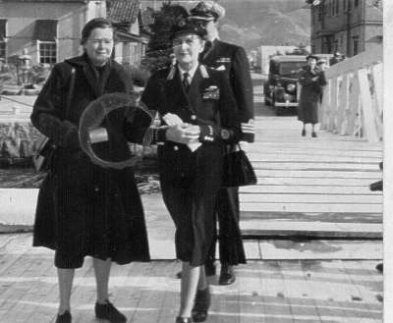

Lady Mountbatten boarding "Kuranda" at HMAS "Commonwealth"

The interpreter in Craft Control was a Japanese civilian called "George" and he was a NEISI (Japanese /American) who happened to be in Japan when WW2 broke out and never did get back to the States. He ran the office and dealt with the boat crews. It didn't take me long to realise that this was a classic case of where "The new broom was not going to sweep clean". Firstly I did not have the experience to do so and secondly "George" would have taken me aside and said, very politely, "that is not a very good idea". If I was posted here to learn, then I was learning and had good teachers. My main function was the "KURANDA" and the BCFK Commander Lt. Gen. Bierworth (Australian) used the "KURANDA" quite a bit for VIP trips. When the "KURANDA" went on task I always accompanied it and had to supply all the answers i.e. position, speed, ETA, ETD, weather, "what island is that", "what ship is that", "could we anchor near that island and go ashore" and last but not least "you are only a L/Cpl and skipper of this vessel- - why is that?". The last was always difficult for me to answer as I would be dammed if I did and dammed if I didn't.
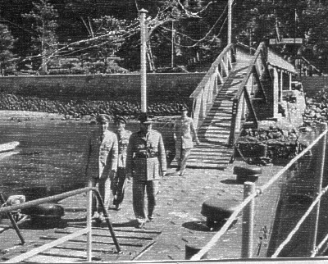

Gen. Lyman Lemnitzer and Lt. Gen. Bierwurth boarding "Kuranda" at Myajima

The "KURANDA" carried quite a lot of VIP's during my time in Japan and included Politicians from many countries, Senior Officers from the U.N. Command as well as Australian senior Officers. The most memorable passengers the "KURANDA" carried in my time were Lady Mountbatten who was on second trip on the " KURANDA" and the Supreme Commander U.N. Forces Korea, Gen. Lyman L. Lemnitzer. Gen. Lemnitzer's Command was held earlier by Gen. MacArthur. We had Gen. Lemnitzer aboard for two trips, one to Myajima and the other was a cruise through the islands North of Kure. On these trips the VIP was always accompanied by the usual necessary staff and on the trip in the Inland Sea the "Staff" had their own communications set up. Our Commander, Lt. Gen. Bierwirth was sometimes accompanied by his wife, always by a Major, sometimes on a local trip by the Chief of Staff Brig. Bruton, and always a Batman. Since anywhere one looked, on the "KURANDA" during one of these trips, there would always be a small group huddled in conversation, I decided to remain on the bridge out of the way. On a few occasions Gen. Lemmnitzer came to the bridge on his own and simply had a chat about nothing in particular. Maybe he just wanted a break from the Military/Political discussions being held. Lt. Gen. Bierwirth was the same and would appear on the bridge frequently to have a chat. When I mentioned one of his Officers who served with him in the Middle East when he was DAQMG of the 6th Division and had asked to pass his regards if the opportunity arose, he was delighted. The Officer concerned was Norm Tinsley from the Penshurst RSL, which had received my weapons "cache" before I left Australia. Sometimes the "KURANDA" would carry only Mrs. Bierwirth and we would simply cruise the islands for a weekend.
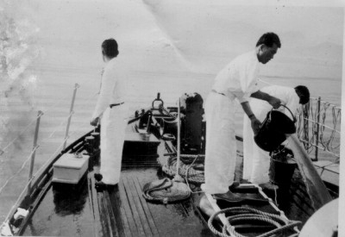

Morning washdown aboard "Kuranda" in the inland sea of Japan

When she left "KURANDA" on the Sunday afternoon a carton of cigarettes was always given to me. ". I was to meet Lord Louis Mountbatten in 1974 in Port Moresby when, as Exec. Officer of PNGDF Landing Craft Squadron (RAN), I was a Liaison Officer to the Royal visit.

The song "Moving On" was a popular parody during the Korean War and the words were changed by the Australian, US and British forces to suit their particular view.

• there's a Momma San a coming down the track
• with her (things) hanging out
• and a Kiwi on her back
• He's moving on, - He'll soon be gone
• for their getting too close to his shacking up post
• He's moving on

• ------
• You hear the pitter pat of a thousand feet
• It's the 1 Div Cav in full retreat
• their moving on, - they'll soon be gone
• for their getting too close to their listening post
• their moving on
• ------
• Ashes to ashes, dust to dust
• if the Aussies don’t get you, then the kiwis must
• their moving on, - they'll soon be gone
• for their getting too close to their shacking up post
• their moving on
• ............................

The "KURANDA" had engine telegraphs fitted and I soon learnt to handle and control her like the 62' Command Craft. The main craft that was a delight to handle was the 62' Command Craft that had been returned to us by the RAAF. Since Point Camp was open to the elements we had secondary protected moorings for the craft which would be used when a Typhoon alert was ordered. This was at "Cassels Camp" and was literally an enclosed basin in which the craft were moored to pontoons, the same as at Point Camp. We had a weather station on a small island adjacent to Point Camp and they hoisted warnings when applicable. We would then move craft and crews to Cassels Camp for the night or until the warning was rescinded. We moved a few times but no Typhoon ever developed.
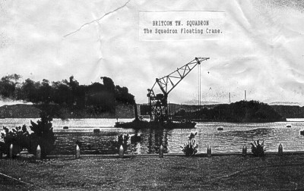

The 75 ton floating crane of Britcom Tn. Squadron

Norm Holdsworth had arrived from Australia, posted as Quay Foreman and worked over at Kure Docks. Bob McLeod had also arrived. As the days of BCFK were numbered it became necessary to bring all the Squadron assets together and these included many accountable items that were still in place in locations that had been superseded and some locations had already been taken over by the Japanese Maritime Defence Force or U.S. units. One of these locations was Nijimura which had shrunk in size from the original size during BCOF days and the Korean War. HQ Aust Army Component now occupied a small part of Nijimura and the remainder had been taken over by the U.S. and possibly some had reverted to Japanese control. At Nijimura and in an area now controlled by the U.S. was a Pontoon Wharf which was still ours and a Task came down the line to get it back to Point Camp. CB1050 and an ALC-20 went around to Nijimura and began the process of collecting the whole thing including buoys and anchors
which was now in a U.S. area. George and I went around in the 62' to see how things were going and while there two American civilians arrived in a car. Their opening statement "What the hell do you guys think you are doing ? " was enough to start an aggressive dialogue from me but I replied very courteously "What the hell does it look like". They informed me that I was removing damaging
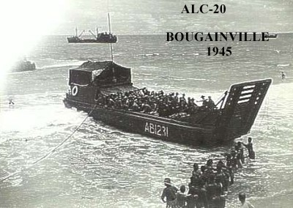

/destroying assets of the U.S.
8th Army which made me ask George "We do have the right Pontoon. don't we?" to which George replied "Yes, we do". I then said to the Americans "It's ours and it is being taken back to Kure to which one of them replied "We'll see about that .....smart arse Aussies" and then jumped in their car and drove off. After the whole thing had been loaded onto CB1050 and the ALC-20. we then departed for Kure and on my mind during the next hour was whether we were right or wrong. Since nothing was ever heard about that particular pontoon wharf I concluded that the intervention by those two Americans was a "Con" job. To me a victory, no matter how small, is just as pleasing as a big victory.

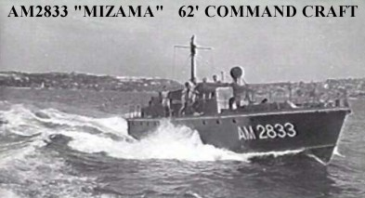
AM2833 was used as a VIP craft in Japan, with blue hull and white superstructure.
It was returned to Australia in the early 50's and was used as a VIP craft in Sydney until sold in the late 60's. She entered the tourist trade on the Great Barrier Reef but burned and became a total loss in the early 80's

The day came for my departure back to Australia and I was paraded before the OC who amongst other things said to me "I could find no fault with your technical ability whatsoever but your performance as a soldier in this unit disturbs me.". Maybe I was getting more experienced as I could think of many replies but I kept my mouth shut. I left Kure by train in company with Kevin Tidy who I later served with in Darwin and Kevin McGinley who later came to Water Transport. Both had been serving with Britcom Engr. Regiment. At Tokyo we spent a couple of days at Ebisu which was closing down and we saw the sights of Tokyo which wasn't quite correct as we never even completed a tour of the Ginza, which would take a week to see all the bars, let alone the very modern department stores. In one bar we went to which was well patronised by Americans a fight started down the other end. We were sitting near the front door and were just talking when one of the opponents pulled a knife and the atmosphere changed rather dramatically. Within a minute or so the bar was invaded by U.S. MP's who began swinging their batons as soon as they entered the door. One of them came to our table, saw the uniforms and said "Get out Aussie!", which we did, rather hurriedly. One of the MP's said to us outside that "We don't take knife fights as routine and we don't know who has one or not so we belt everybody". Democracy at work is fine to see.

We departed Tokyo at midnight on a BOAC flight. Looking at the aircraft, which was a Canadian version of the DC-4 but was powered with Rolls Royce Merlin engines and looking at the number of people being put on board made me think that it would probably be better to walk and as soon as those engines started I was sure it would be better to walk. The noise from the RR Merlins was so loud at idle speed that it was impossible to have any conversation whatsoever. Also, as passengers on the plane were a large group of Japanese communists who were on their way to London for a workers rally and then onto the big rally in Moscow. We went down to Okinawa and landed at Kadena AFB and apart from a few others we were the only ones allowed to leave the aircraft. The Jap communists were definitely not the flavour of the month at Kadena and there were guards around the aircraft to make sure they did not get off. We had a two hour stopover and then onto Hongkong.

At Hongkong we were to pick up the QANTAS DC-4 but it had problems elsewhere so we were put into the "INTERNATIONAL" hotel for a few days. While there we went up to the Peninsula Hotel for some reason or other and they were filming a movie with Clark Gable and Susan Hayward so we had a look at that for a while. We then booked on the Ferry to Macao which was down the coast a little. It appeared that the Chinese communists were stopping the ferry and taking off those who did not fit the communist ideal or those who could provide political mileage for them. We did not go to Macao. In the hotel were a group of USAF pilots who were flying F-86 "Sabres" for the Nationalist Chinese on Formosa. The Americans were not involved in Formosa as it would upset the communists and these pilots were not there but they were and it all became confusing. They had downed two MIG's the week before and were in Hongkong courtesy of the Nationalists. They kept buying the drinks and in the end I sold one of them my Slouch hat for 15 pounds. They were a fine group but as the Bourbon got to them and they opened up, the only thing they were looking forward to be getting out of Formosa and back to the States.

Our aircraft finally arrived and we went to Manila where we stopped another two days at the Bayview Hotel and then down to Labuan for a day and then to Darwin. There were about a dozen Japanese war brides on the aircraft and they could not comprehend the size of Australia from Darwin to Sydney. The aircraft was flying at 12000 feet and they saw bushfires in the Territory extending from one side of the aircraft to the other, desert and floods. On arrival in Sydney we were taken out to the Personnel Depot at Marrickville and went on leave. Personnel Depots were notorious for keeping people as long as possible. After leave how long

was I going to languish at Marrackville?. They kept me there for six weeks after I had finished leave and then I went back to Chowder Bay.

Upon returning to Chowder Bay I took over AM1558 as Coxswain for a couple of months and then attended an RAAF Course at East Sale which was an Instructors Course in Aerial Photo interpretation and Aircraft, Ship and Armoured Fighting Vehicle recognition. The Aircraft and Ships side of the course were a breeze as I was a keen student of aircraft since my school days and since joining the Army I had read and studied everything that I could get my hands on in reference to ships and in particular Amphibious warfare. The part of the course that I knew little of was Aerial Photography Interpretation and this I wanted to know more about. The difference between the RAAF school at East Sale and Chowder Bay was beyond comparison. At East Sale the facilities available to students included the very latest aids such as the production of slides to make a presentation and above all the text books were of Australian origin and the content was directly related to the course syllabus. There were two other Army NCO's on the course and as usual I was the odd man out as all students were Sgt. and above. One aspect that really "got me in" was using a Stereoscope to find and identify objects, situations etc. from two identical photographs that could not be determined from one photograph. I did not think that I would ever be in a position to use this knowledge but I did later in Darwin and, in a much wider scope, in New Guinea.. The course would be the only course that I attended on which all the course content taught was used by me in the remainder of my career

On my return to Chowder Bay I became the "Bosun" of AV2770 "SANDRA". The term "Bosun" was used rather lightly as the "SANDRA" was not being used and I was used to keep it clean..

In 1957 I was back aboard AV1379 "TARRA" in New Guinea as wireless operator. I Norm Stark was still the Master and I still kept a deck watch as well as Wireless Operator. The radio installed was the "Australphone" and from the look of it and its output power it surely must have been the lowest tender. It was nowhere as good as the 3BZ we used in 1955 and in Japan on the "KURANDA". However a welcome innovation was that Radar was installed on "TARRA", a Decca 212 set. The run was exactly the same as 1955 in regards to destinations and cargo.

One of the Deck crew, Bill Saylor, was a Darnley Islander and on leaving Moresby we went via Bramble Cay to Darnley Island. Darnley is virtually at the top of the Barrier Reef and Bill was being dropped off to have his annual leave. We anchored overnight and put out a heavy set line with two four gallon drums attached. In the morning we had a massive Tiger Shark attached to the large hook We could not pull the shark inboard so we attached it to one of the Lifeboat Davits and hauled it clear of the water. The Tiger Shark was 11 feet long from tip to tail. It was handed over to the Darnley Island people before our departure for Cairns and Brisbane.

On return to Sydney and Chowder Bay I was advised that I was to be posted to Darwin. By this time I could not help but feel that as soon as I returned to Chowder Bay "they" would be on the phone to Canberra to find a place, as far away from Chowder Bay as possible, that I could be sent to. It was either that or I had a fairy Godmother

